FITNESS Zone Health & Fitness Club
6th Annual Jingle Bell 5K
Run & Walk
Palmetto Grand Prix Race – USATF CERTIFIED COURSE
Proceeds go toward promoting health & exercise programs for Kershaw County Youth

Saturday, December 7, 2013 @ 8:00am

LOCATION: Fitness Zone, 814 Hwy 1 South, Lugoff, SC / (803) 438-3811

REGISTRATION: Online @ www.strictlyrunning.com or registration form below

ENTRY FEES: Registration $ 25
Late Registration (after 11/07/13) 30
Race Day Registration (12/07/13) 35

The Jingle Bell Run is chip-timed and is part of the Tour de Columbia. Awards for the top three males & females in each age group will be given. Overall awards are given for the top male and female winner.
Overall winners are not eligible for age group awards.

Packet pick-up @ Fitness Zone: Friday, 12/06/13, 12:00 PM – 8:00 PM,
or on race morning @ 7:00AM

~Race shirts guaranteed with all 5k registrations prior to 11/07/13~

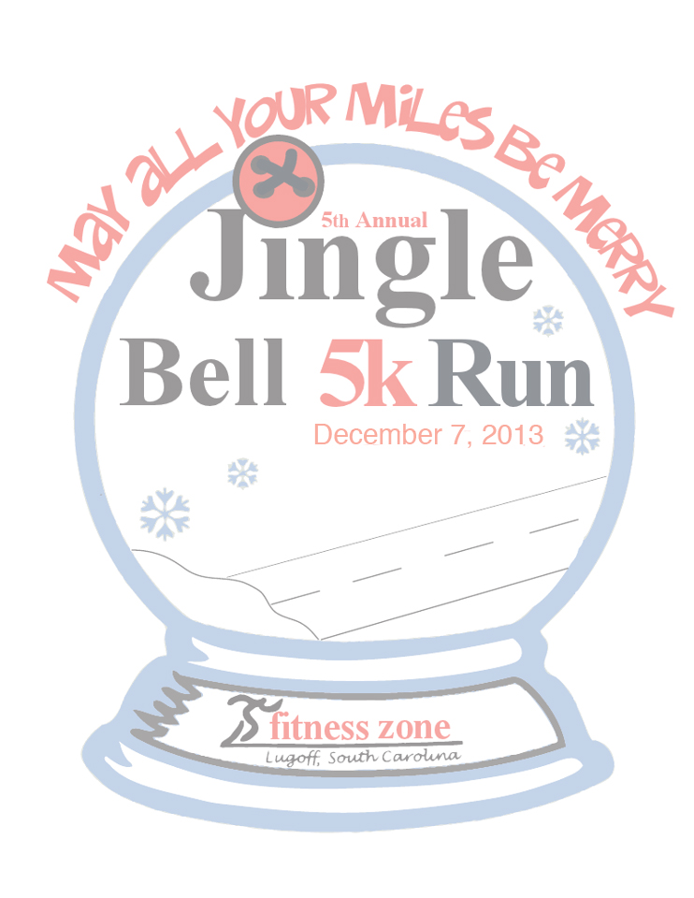
EVENT (please circle): 5K Run 5K Walk

RACE DAY AGE______ BIRTHDAY_____/_____/________

Name: ______________________________________________________________ CIRCLE: Male / Female

Address: ________________________________________________________________________________________

Email: _____________________ ___________________________________________Phone:_____________________

Emergency Contact (Name & Phone): _________________________________________________________________

T-Shirt: S M L XL XXL

The entrant releases sponsors and officials of the Fitness Zone Jingle Bell Run/Walk from all claims of injury or damages resulting from participating in this event. I am in proper physical condition to participate in this event. * Make checks payable to Fitness Zone

Signature (Parent or Guardian if under 18) __________________________________ Date: _______________

Mail to: Fitness Zone, P0 Box 459, Lugoff, SC 29078
Or Register online at: www.strictlyrunning.com

